In Name of Free Speech, States Crack Down on Campus Protests
https://www.nytimes.com/2018/06/14/us/politics/campus-speech-protests.html?emc=edit_th_180615&nl=todaysheadlines&nlid=669417280615
By Jeremy W. Peters
June 14, 2018
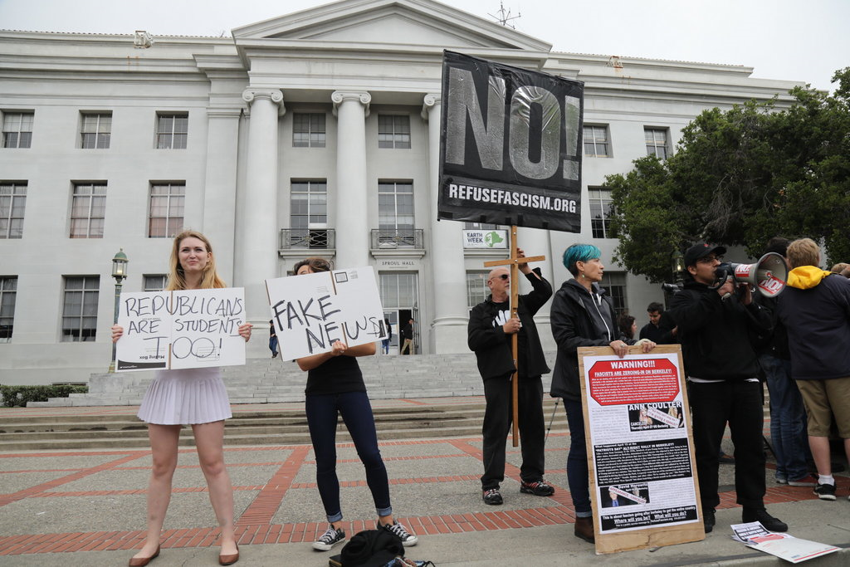
Students from a Republican group at the University of California, Berkeley, protesting next to an anti-fascist group after the conservative writer Ann Coulter canceled a speech at the school in April 2017. Credit: Jim Wilson/The New York Times
When the Board of Regents of the University of Wisconsin wanted to address the issue of free speech on campus last fall, it adopted a three-strikes policy that is the strictest of its kind: Any student found to have disrupted the free expression of others is expelled after a third infraction.
The goal was to foster an atmosphere of “civility, respect and safety,” and avoid the kind of violent, unruly disruptions that prevented conservatives from speaking at schools like the University of California, Berkeley, and Middlebury College. Those protests had focused national attention on the question of whether college campuses were shutting out politically unpopular points of view.
Wisconsin is not alone. Republican-led state legislatures in Arizona, Georgia and North Carolina have imposed similar policies on public colleges and universities, and bills to establish campus speech guidelines are under consideration in at least seven other legislatures. These efforts, funded in part by big-money Republican donors, are part of a growing and well-organized campaign that has put academia squarely in the cross hairs of the American right.
The spate of new policies shows how conservatives are successfully advancing one of their longstanding goals: to turn the tables in the debate over the First Amendment by casting the left as an enemy of open and free political expression on campuses. It was at schools like Berkeley, after all, that the free speech movement blossomed in the 1960s.
The new efforts raise a question that has only grown more intractable since President Trump took office: When one person’s beliefs sound like hate speech to another, how do you ensure a more civil political debate?
What conservatives see as a necessary corrective to decades of political imbalance in higher education, liberals and some college administrators see as an overly paternalistic approach to a problem that is being used as ammunition in the culture wars.
“It has this strong motivating factor when it appeals to the politics of resentment,” said Donald Moynihan, director of the La Follette School of Public Affairs at the University of Wisconsin-Madison, who opposed the regents’ policy.
Mr. Moynihan added that conservatives are pushing these policies because of “the sense that there are these elite institutions where your voice is not being heard, and where your beliefs are somehow being devalued.”
The campaign to address speech issues at colleges and universities is unfolding not just in state legislatures but in the courts and in Congress, where Republicans have convened hearings to explore how colleges and universities are addressing free speech concerns.

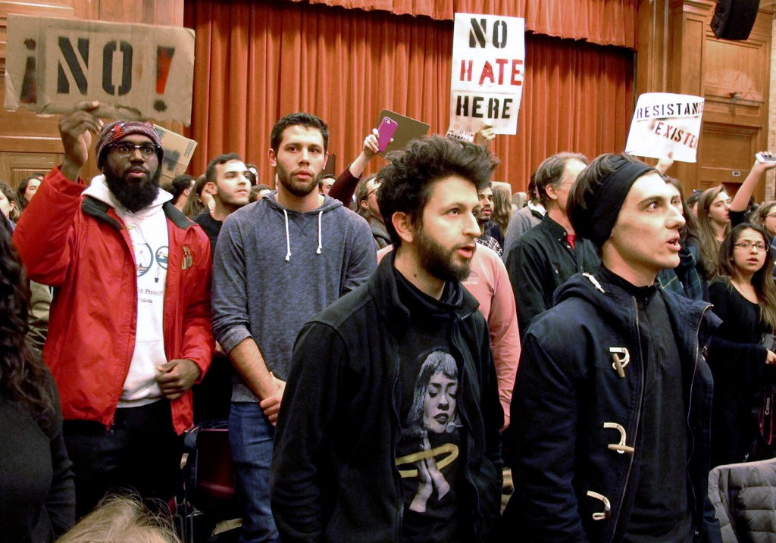
Students at Middlebury College in Vermont turned their backs to Charles Murray, an author who had been invited by a conservative student group, during his lecture in March 2017. Credit: Lisa Rathke/Associated Press
The Trump administration has also picked up the baton. In March when the White House convened a discussion called “Crisis on College Campus,” it identified two coequal culprits: opioid abuse and suppression of free speech. This week the Justice Department formally filed a statement in support of a lawsuit challenging the University of Michigan for establishing “bias response teams,” which assist students who claim to have been victims of offensive conduct. The filing called the university’s policies “chilling” on free speech.
The issue is a natural fit for President Trump, who has made fighting political correctness and pushing boundaries central to his identity.
“Increasingly, when conservatives make their points, they are told, whether directly or in a roundabout way, ‘Shut up, you’re a bad person,’” said Stanley Kurtz, co-author of model campus speech legislation being promoted by the Goldwater Institute, named for Barry Goldwater, the archconservative former senator.
Several states have taken up the Goldwater model or adopted it in part. The Wisconsin regents, almost all of whom are appointed by the Republican governor, Scott Walker, borrowed from it. Lawmakers in North Carolina and Georgia did as well.
Mr. Kurtz said that shout-downs of conservatives at colleges are a far more serious problem than the left admits, calling them “an open embodiment of a problem that runs more subtly through far too much of our political discourse.”
The Goldwater Institute has been funded by some of the biggest benefactors in Republican politics. They include the Mercer family of New York, whose foundation has given more than $1.1 million since 2012, tax filings show. Rebekah Mercer, who oversees much of her family’s giving, has served on the institute’s board.
Another leading conservative policy group, the Alliance Defending Freedom, has sued schools in Georgia, Michigan and other states for restricting demonstrations to designated areas on campus, sometimes referred to as “free speech zones.” The group, which just successfully defended before the Supreme Court a Colorado baker who refused to make a cake for a gay wedding, has been able to force some colleges to revise their policies.
The cause also has its own news service, a website called Campus Reform, which mocks liberalism taken to the extreme. One of its recurring segments, for example, shows interviews with students on questions like whether St. Patrick’s Day celebrations amount to cultural appropriation. The site is a project of the Leadership Institute, another big player in the conservative movement.
Many liberals agree that universities should be extremely judicious in how they regulate political expression. They also say that Republican lawmakers are stifling free speech in the name of protecting it by forcing codes of conduct on universities.
“The big irony is that their solution is right-wing social engineering,” said Michael Behrent, an associate professor of history at Appalachian State University in North Carolina and a co-author of a new report, for the American Association of University Professors, on speech legislation.

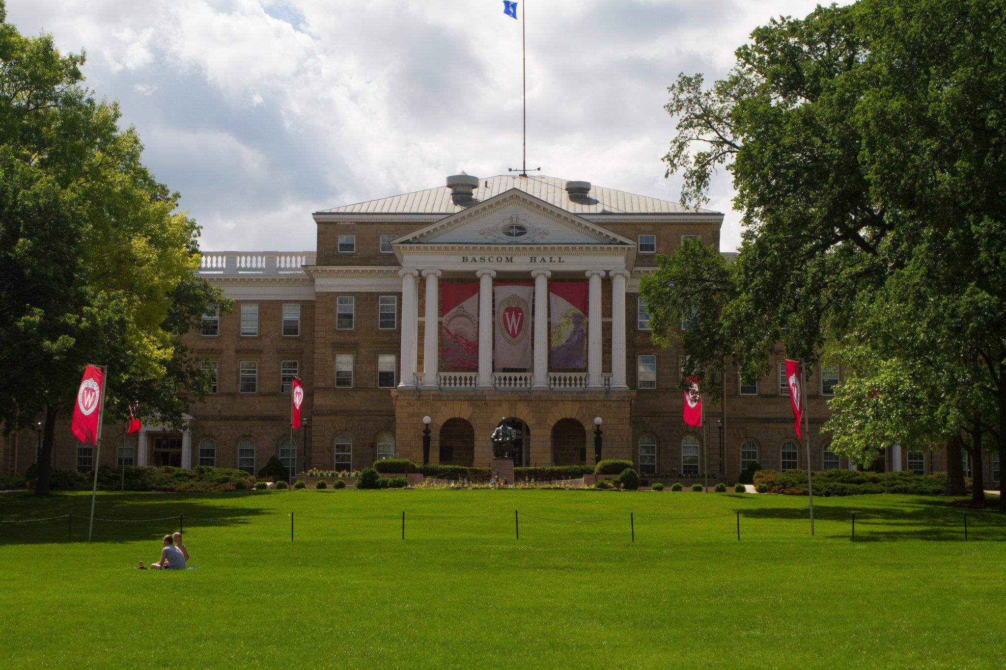
The University of Wisconsin has implemented a strict, three-strikes policy regulating protests of those who speak at the school. Credit: Jon Elswick/Associated Press
“They’re supposedly against the idea of speech codes and authorities regulating what can and cannot be said,” Mr. Behrent added. “But they really are in fact advocating that.”
The Goldwater model makes several recommendations for colleges and universities: to create disciplinary sanctions, including expulsion, for students who have been found to have twice interfered with someone’s free expression; to prevent administrators from disinviting speakers, no matter how controversial; and to remain neutral on the controversies of the day.
The model is not without disagreement on the right, however. Its mandatory punishment provisions drew a rebuke from the Charles Koch Institute, one of whose directors said conservatives were “giving in to the same fragility of which they so freely accuse their liberal counterparts.’’ Mr. Koch’s foundation has been a contributor to the institute in the past.
More broadly, some powerful Republicans are questioning whether affirmative action should be extended beyond race to students with less commonly held political views.
“You did it for underrepresented students, do it for underrepresented points of view,” said Senator Lamar Alexander, Republican of Tennessee and the chairman of the Senate Committee on Health, Education, Labor and Pensions. In his comments, which he made at a New York Times conference on higher education last month, Mr. Alexander said that if colleges did not prioritize political diversity, they risked graduating a generation of overly squeamish adults.
“We don’t want a whole generation of students who have to go to a safe room when they read an offensive tweet,” he said. “They need to learn how to deal with that in our society.”
Lt. Gov. Dan Forest of North Carolina, who led the effort to pass the state’s Goldwater-modeled law, said, “If you want to shut down the discussion, that’s called communism.”
Conservatives say that one of their biggest concerns is a growing misunderstanding about what “free speech” means and how the principle is selectively enforced. They point to the slogan used by many liberals today, “Hate Speech is Not Protected Speech,” as an example of how distorted the debate has become. (The First Amendment protects speech regardless of how offensive it is.)
“Whatever the standard is for right-wing hate speech must be the standard for left-wing hate speech,” said Alan Dershowitz, a professor emeritus at Harvard Law School, who also spoke at The Times’s higher education conference.
The role that lawmakers have in setting those standards is what remains so divisive.
“We’ve had students protesting forever and speech survives,” Mr. Moynihan, the professor of public affairs, said. He pointed to the 2016 appearance at Wisconsin-Madison campus by Ben Shapiro, the conservative writer whose addresses have sparked outbursts on campuses across the country. Student protesters interrupted him and at one point tried to obstruct the stage. But they eventually left on their own, and Mr. Shapiro continued with his remarks.
That was a year before the regents adopted the new code of conduct. Since its implementation, few controversial conservative headliners have come to campus. And according to the university, no student has been expelled.

Follow Jeremy W. Peters on Twitter: @jwpetersNYT.
A version of this article appears in print on June 15, 2018, on Page A11 of the New York edition with the headline: In Name of Free Speech, a Crackdown on Campus Protests. Order Reprints | Today’s Paper | Subscribe

